**Shurima Project Manager**

**Shurima Project Manager** is an application that helps user **manage their projects**. Projects are **sorted** **descending** **based on its difficulty**. Your task is to develop this application using **Priority Queue Concept implemented in Linked List**. Below are the **detail requirements** of this application.

* **Shurima Project Manager** consist of **four menus**:

1. **Register New Project**
2. **Assign Project to Programmer**
3. **View Unassigned Project**
4. **Exit**

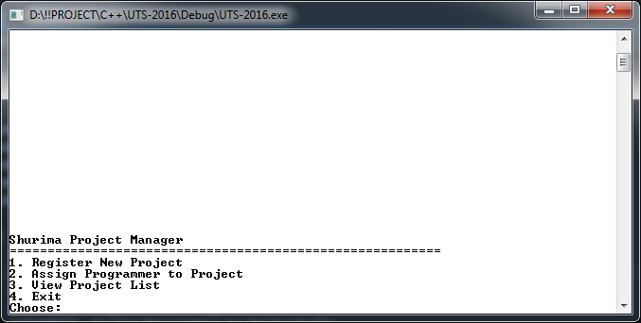

Figure . Main Menu of Shurima Project Manager

* **Menu 1: Register New Project**
* User can **register** their project via this menu
* Ask user to input **Project Name**. Validate **Project Name** **between 8 and 35 characters**
* Ask user to input **Project Difficulty**. Validate **Project Difficulty** must be a **number between 1 and 10**. **Higher number means higher difficulty**.
* Projects will be **stored in descending order based on its difficulty**.
* If there are **two or more projects with same difficulty**, the **latest project will be listed after the prior project**.

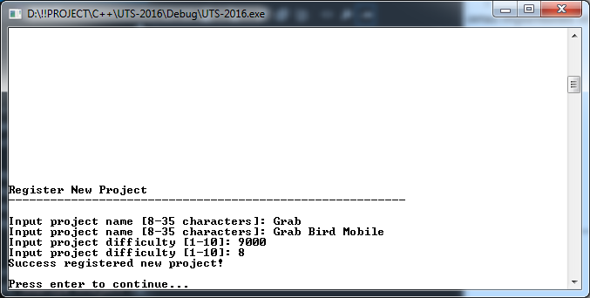

Figure . Register New Project

* **Menu 2: Assign Programmer to Project**
* User can **assign programmer** to finish the project.
* Every time programmer is assigned, **the** **project will be removed from the list**.
* User can only **assigned programmer to project with the highest difficulty on the list one each time**
* **Show a message telling which project is recently assigned**

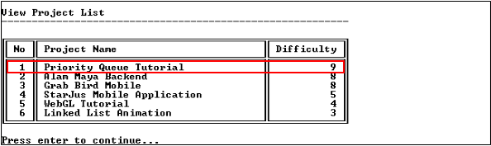

Figure . View Project List (Before Assign Programmer to Project)

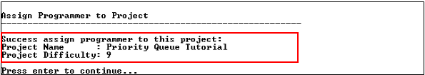

Figure . Assign Programmer to Project

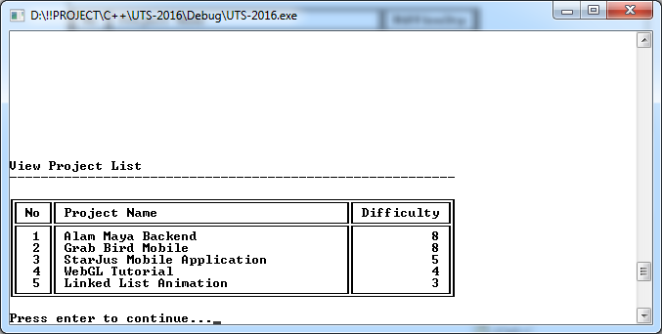

Figure . View Project List (After Assign Programmer to Project)

* **Menu 3: View Project**
* User can **view project list** via this menu

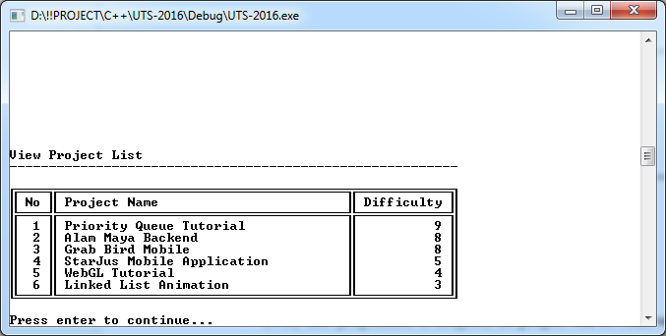

Figure . View Project List

* **Menu 4: Exit**
* User can **exit from application** via this menu
* **Remove the remaining data existed in the memory**

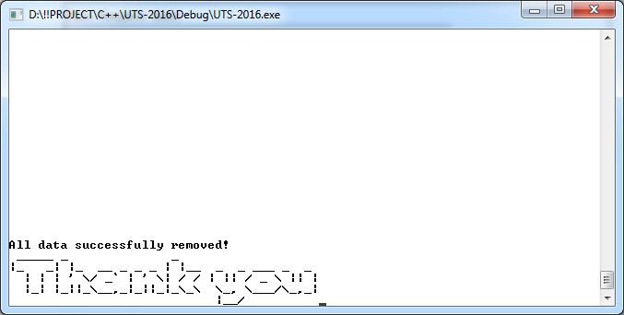

Figure . Exit